| **Team Number** | 07 | **Section** | 05 |
| --- | --- | --- | --- |
| **Team Members** | 1. Minh Le 2. Seyed Morsali 3. Quang Tang 4. Van Chuong Pham | | |
| **Software Name** | Password Manager | | |

## Problem Statement

Computers and the Internet are being used extensively and the security of users' privacy has become a big issue. One of the oldest ways to provide security is using passwords. Choosing and storing passwords are hard tasks for the majority of the users and cause millions of breaches. Since the number of websites that we use every day is increasing, this causes most users to choose simple memorable passwords, store them improperly, or reuse them for many websites/applications that increase the risk of being cracked. The existing password managers are not reliable because there is always the risk of leaking our information to the developers of the software!

## Functional Requirements

The password manager should have the following minimum features:

1. The application shall be multiuser.
2. The user shall log in/signup/reset the password when running the application.
3. The user's login password (aka master password) shall be reset by one

security question that is set during signup.

1. The application shall store the username, password, website/application name, specified email, creation date, expiration date
2. The application shall generate a password based on the given criteria:

* Minimum/maximum lengths of the generated password can be set to any non-zero positive integer
* The option of including special characters (!"#$%&'()*+,-./:;<=>?@[\]^_`{|}~)
* The option of including capital letters. In this case, the user needs to specify how many capital letters are required.

1. The passwords shall be encrypted before storing and decrypted before retrieving. For security purposes, the code of encryption/decryption will be provided by the client (the professor).
2. The password shall be copied in the clipboard by a button.
3. The application shall warn the user about the expired passwords right after successful login to the system.
4. The user shall search based on the website/application name or username.
5. The user shall modify the information of the application.

* When the user updates the duration of the password, the current expiration day will not change. New duration will apply for the next time when the user updates their old password.

## References

N/A

## Use Cases

1. **Login menu:**

| **Use Case Name** | | Login | |
| --- | --- | --- | --- |
| Goal | | | |
| This use case describes how a user login into the system. | | | |
| Participating Actors | | | |
| User, System. | | | |
| Glossary | | | |
| N/A | | | |
| Primary Flow of Events | | | |
| Trigger | | | |
| User runs the application and get in login menu | | | |
| **Steps** | **Action** | | **System Response** |
| 1 | Run the application | |  |
| 2 |  | | Show the login menu |
| 3 | Enter username and passwords then press “Login” | |  |
| 4 |  | | Verify username and password |
| 5 |  | | checks if any record has an expired password |
| 6 |  | | Show “the main menu” if the system does not found any expired password |
| Alternate Flow of Events | | | |
| Alternate Trigger | | | |
| The System finds some passwords are expired and show it before entering into main menu | | | |
| Steps | **Action** | | **System Response** |
| 1 | Run the application | |  |
| 2 |  | | Show the login menu |
| 3 | Enter username and passwords then press “Login” | |  |
| 4 |  | | Verify username and password |
| 5 |  | | check if any record has an expired password |
| 6 |  | | Show the “Expired password” menu if it found any expired record |
| Alternate Flow of Events | | | |
| **Alternate Trigger** | | | |
| The user enters wrong password or username | | | |
| **Steps** | **Action** | | **System Response** |
| 1 | Enter the wrong username or password | |  |
| 2 |  | | Show the message in red “ Wrong user name or password. Please try again” |
| Alternate Flow of Events | | | |
| **Alternate Trigger** | | | |
| The user click on the signup button | | | |
| **Steps** | **Action** | | **System Response** |
| 1 | Click on sign up button | |  |
| 2 |  | | Redirects the user to the Signup menu |

| **Use Case Name** | | Sign Up Button | |
| --- | --- | --- | --- |
| Goal | | | |
| This use case describes how a user signs up new account | | | |
| Participating Actors | | | |
| User, System. | | | |
| Glossary | | | |
| N/A | | | |
| Primary Flow of Events | | | |
| Trigger | | | |
| - User runs the application  - User clicks on "Sign up" button | | | |
| **Steps** | **Action** | | **System Response** |
| 1 | Run the application | |  |
| 2 |  | | Show the login menu |
| 3 | Click on “Sign Up” button | |  |
| 4 |  | | Show the “Sign Up” menu |
| 5 | Enter username, passwords, re-enter password, security question, and answer | |  |
| 6 | Click “Submit” button | |  |
| 7 |  | | Verifies username, passwords, re-enter password, security question, and answer |
| 8 |  | | Show the message” Creating a new account is successfully done!” |
| 9 |  | | Show the “Main menu” |
| Alternate Flow of Events | | | |
| **Alternate Trigger 1** | | | |
| The user enters an invalid username or password | | | |
| **Steps** | **Action** | | **System Response** |
| 1 | Enter the invalid username or password | |  |
| 2 |  | | Show the message in red “ your user name or password is invalid. Please try again” |
| **Alternate Trigger 2** | | | |
| The user enters an existing User Name | | | |
| **Steps** | **Action** | | **System Response** |
| 1 | Enter a username that is already taken | |  |
| 2 |  | | Show the message in red “ User name already exists. Please try again”. |
| **Alternate Trigger 3** | | | |
| The user clicks the “Cancel” button | | | |
| **Steps** | **Action** | | **System Response** |
| 1 | Click “Cancel” button | |  |
| 2 |  | | Show the “login” menu |

| **Use Case Name** | | Reset Master Password | |
| --- | --- | --- | --- |
| Goal | | | |
| This use case describes how a user reset a master password | | | |
| Participating Actors | | | |
| User, system | | | |
| Glossary | | | |
| N/A | | | |
| Primary Flow of Events | | | |
| Trigger | | | |
| - User runs the application and get into login menu  -User clicks on "Forgot Password" button | | | |
| **Steps** | **Action** | | **System Response** |
| 1 |  | | Show reset master password username menu and ask username |
| 2 | Enter username | |  |
| 3 | Press submit | |  |
| 4 |  | | Show the menu with security question |
| 5 | Enter the answer for security question | |  |
| 6 |  | | Show the menu to set new password |
| 7 | Enter a new password and re-enter password | |  |
| 8 | Click Submit | |  |
| 9 |  | | Show the message “ Success change password” |
| 10 | Click “Login” button | |  |
| 11 |  | | Return to log in menu |
| Alternate Flow of Events | | | |
| **Alternate Trigger** | | | |
| The user enters the wrong answer for security question | | | |
| **Steps** | **Action** | | **System Response** |
| 1 | Enter the wrong answer for security question | |  |
| 2 |  | | Show the message in red “ Wrong answer. Please try again” |
| Alternate Flow of Events | | | |
| **Alternate Trigger** | | | |
| The user clicks the “Submit” button before filling in a new password or invalid new password | | | |
| **Steps** | **Action** | | **System Response** |
| 1 | Click on “Submit” button | |  |
| 2 |  | | Show the red message “Invalid new password. Please try again.” |
| Alternate Flow of Events | | | |
| **Alternate Trigger** | | | |
| User enters a non-existing user name | | | |
| **Steps** | **Action** | | **System Response** |
| 1 | Enter non-existing username in “Password resetting username” menu, and click submit | |  |
| 2 |  | | Show the red message “Invalid username. Please try again.” |

1. **Setting menu**

| **Use Case Name** | | Change Master Password | |
| --- | --- | --- | --- |
| Goal | | | |
| User change Master Password | | | |
| Participating Actors | | | |
| User, System. | | | |
| Glossary | | | |
| N/A | | | |
| Primary Flow of Events | | | |
| Trigger | | | |
| -User logins into the System  -User clicks on "Setting" button | | | |
| **Steps** | **Action** | | **System Response** |
| 1 |  | | Show the Setting menu |
| 2 | Click on “Change” button on the “Master Password” line | |  |
| 3 |  | | Show the Change Master Password menu |
| 4 | Enter Old, New, Re Enter Password and clicks on “Submit” button | |  |
| 5 |  | | Verifies old password, new password, re-enter password, and change to new password |
| 6 |  | | Show the message “Show the message” Changing the record is successfully done!”” in 10 seconds |
| 7 |  | | Show the Main menu |
| Alternate Flow of Events | | | |
| **Alternate Trigger** | | | |
| User clicks on “Main” button in Setting menu | | | |
| **Steps** | **Action** | | **System Response** |
| 1 | Click on “Main” button | |  |
| 2 |  | | Show Main menu |
| Alternate Flow of Events | | | |
| **Alternate Trigger** | | | |
| User clicks on “Cancel” button in Change Master Password menu | | | |
| **Steps** | **Action** | | **System Response** |
| 1 | Click on “Cancel” button | |  |
| 2 |  | | Show Setting menu |
| Alternate Flow of Events | | | |
| **Alternate Trigger** | | | |
| User enters wrong old password | | | |
| **Steps** | **Action** | | **System Response** |
| 1 | User enters wrong old password | |  |
| 2 |  | | Show message “Enter the wrong password, please try again!” |
| 3 |  | | Show Change Master Password menu |
| Alternate Flow of Events | | | |
| **Alternate Trigger** | | | |
| User enters a new password and reenter password don’t match | | | |
| **Steps** | **Action** | | **System Response** |
| 1 | User enters a new password and reenter password don’t match | |  |
| 2 |  | | Show message “passwords do not match, please try again” |
| 3 |  | | Show Change Master Password menu |

| **Use Case Name** | | Change Master Security Question and Answer | |
| --- | --- | --- | --- |
| Goal | | | |
| User change Master Security Question and Answer | | | |
| Participating Actors | | | |
| User, System. | | | |
| Glossary | | | |
| N/A | | | |
| Primary Flow of Events | | | |
| Trigger | | | |
| -User logins into the System  -User clicks on "Setting" button in “Main menu” | | | |
| **Steps** | **Action** | | **System Response** |
| 1 |  | | Show the Change “Master Security Question and Answer” menu |
| 2 | Enter Master Password, New Question, New Answer and clicks on “Submit” button | |  |
| 3 |  | | Verifies master password and change the new question, and new security answer |
| 4 |  | | Show the message “Show the message” Changing the record is successfully done!” |
| 5 |  | | Show the Main menu |
| Alternate Flow of Events | | | |
| **Alternate Trigger** | | | |
| User clicks on “Main” button in Setting menu | | | |
| **Steps** | **Action** | | **System Response** |
| 1 | Click on “Main” button | |  |
| 2 |  | | Show Main menu |
| Alternate Flow of Events | | | |
| **Alternate Trigger** | | | |
| User clicks on “Cancel” button in Change Master Security Question and Answer menu | | | |
| **Steps** | **Action** | | **System Response** |
| 1 | Click on “Cancel” button | |  |
| 2 |  | | Show Setting menu |
| Alternate Flow of Events | | | |
| **Alternate Trigger** | | | |
| User enters wrong master password | | | |
| **Steps** | **Action** | | **System Response** |
| 1 | User enters wrong master password | |  |
| 2 |  | | Show message “Enter the wrong password, please try again!” |
| 3 |  | | Show the Change Master Security Question and Answer menu |

## Main menu:

| **Use Case Name** | | Add new application information | |
| --- | --- | --- | --- |
| Goal | | | |
| User add new application data | | | |
| Participating Actors | | | |
| User, System. | | | |
| Glossary | | | |
| N/A | | | |
| Primary Flow of Events | | | |
| Trigger | | | |
| -User logins into the System and get into “Main menu” | | | |
| **Steps** | **Action** | | **System Response** |
| 1 | Click on “Add” Button | |  |
| 2 |  | | Show the Add Application menu |
| 3 | Enter Application Name, User Name, Password, Re-enter Password, and Email, password duration | |  |
| 4 | Click on “Submit” button | |  |
| 5 |  | | Verifies Password and Re-enter Password |
| 6 |  | | ask if user confirm adding |
| 7 | user confirm by clicking ok on “adding confirmation menu” | |  |
| 8 |  | | Show the message “ Adding a new record is successfully done!” |
|  | Users click on ok button. | |  |
| 9 |  | | Show the “Main menu” |
|  |  | |  |
| Alternate Flow of Events | | | |
| **Alternate Trigger** | | | |
| User enter Password and Re-enter Password don’t match | | | |
| **Steps** | **Action** | | **System Response** |
| 1 | User enter Password and Re-enter Password don’t match | |  |
| 2 |  | | Show message “Passwords do not match. please try again!” |
| 3 |  | | system Show the Add Application |
| Alternate Flow of Events | | | |
| **Alternate Trigger** | | | |
| User click cancel button | | | |
| **Steps** | **Action** | | **System Response** |
| 1 | Click cancel button | |  |
| 2 |  | | Return to “ Main menu” |

## Expired password menu

| **Use Case Name** | | user change expired password | |
| --- | --- | --- | --- |
| Goal | | | |
| User set a new password for an expired password | | | |
| Participating Actors | | | |
| User, System. | | | |
| Glossary | | | |
| N/A | | | |
| Primary Flow of Events | | | |
| Trigger | | | |
| * User logins into the System * System check if there is expired password in the Database * System shows “expired password menu” | | | |
| **Steps** | **Action** | | **System Response** |
| 1 | Click on “Update pass” Button | |  |
| 2 |  | | Show “Change password menu” |
| 3 | User enter new password | |  |
| 4 | users enter the new password again | |  |
| 5 | users click submit | |  |
| 6 |  | | Verify old password, new password, and reenter the password. |
| 7 |  | | Save new password |
| 8 |  | | Show the message” Changing the record is successfully done!” |
| 9 |  | | system get back into “expired password menu” |
| Alternate Flow of Events | | | |
| **Alternate Trigger** | | | |
| User enter Password and Re-enter Password don’t match | | | |
| **Steps** | **Action** | | **System Response** |
| 1 | User enter Password and Re-enter Password don’t match | |  |
| 2 |  | | Show message “Passwords do not match. Please try again!” |
| 3 |  | | system Show “Change password menu” |
| Alternate Flow of Events | | | |
| **Alternate Trigger** | | | |
| User click cancel button | | | |
| **Steps** | **Action** | | **System Response** |
| 1 | Click cancel button | |  |
| 2 |  | | Return to “Application information” |

## Search menu

| **Use Case Name** | | Searching for a password of an application | |
| --- | --- | --- | --- |
| Goal | | | |
| User can search for a list of application password | | | |
| Participating Actors | | | |
| User, System. | | | |
| Glossary | | | |
| N/A | | | |
| Primary Flow of Events | | | |
| Trigger | | | |
| User logins into the System and get to “Main men” | | | |
| **Steps** | **Action** | | **System Response** |
| 1 | click search button | |  |
| 2 |  | | Show the “Search menu" |
| 3 | Fill in at least one category application, emails, or user name | |  |
| 4 | Click submit | |  |
| 5 |  | | Show the list of application that match one of the category |
| Alternate Flow of Events | | | |
| **Alternate Trigger** | | | |
| User click cancel button in searching page | | | |
| **Steps** | **Action** | | **System Response** |
| 1 | user click cancel | |  |
| 2 |  | | Return to the “Main menu” |

## Application information menu:

| **Use Case Name** | | Change email using for Application/Website | |
| --- | --- | --- | --- |
| Goal | | | |
| User change email | | | |
| Participating Actors | | | |
| User, system | | | |
| Glossary | | | |
| N/A | | | |
| Primary Flow of Events | | | |
| Trigger | | | |
| * User login and get in to “Main menu” * User Click “Edit” button next to application name in “Main menu” * User click “ Change” button next to email in “Application information menu” | | | |
| **Steps** | **Action** | |  |
| 1 | User enter new email | |  |
| 2 | Users enter new email again | |  |
| 3 | User click submit | |  |
| 4 |  | | System verify new email, re-enter email |
| 5 |  | | Ask if user confirm the change |
| 6 | User click ok | |  |
| 7 |  | | Show the message” Changing the record is successfully done!” |
| 8 |  | | System save new email, and return to “Application information menu”. |
| Alternate Flow of Events | | | |
| **Alternate Trigger** | | | |
| * Enter Different Email and re-enter Email | | | |
| **Steps** | **Action** | |  |
| 1 | user enter different Email and re-enter email | |  |
| 2 |  | | Show the red Message “ Email and re-enter email does not match. Please retry!” |

| **Use Case Name** | | Change username using for Application/Website | |
| --- | --- | --- | --- |
| Goal | | | |
| User change username | | | |
| Participating Actors | | | |
| User, system | | | |
| Glossary | | | |
| N/A | | | |
| Primary Flow of Events | | | |
| Trigger | | | |
| * User login * User click “Edit” button next to an application in “Main menu” * User click “ Change” button next to username in “Application information menu” | | | |
| **Steps** | **Action** | |  |
| 1 | User enter new username | |  |
| 2 | User click submit | |  |
| 3 |  | | System save new username, |
| 4 |  | | Show the message” Changing the record is successfully done!” |
| 5 |  | | System return into “Application information menu” |
| Alternate Flow of Events | | | |
| **Alternate Trigger** | | | |
| * user decide to cancel | | | |
| **Steps** | **Action** | |  |
| 1 | user click on cancel button | |  |
| 2 |  | | system get back to the “application information menu” |

|  | | Change password duration days for Application/Website | |
| --- | --- | --- | --- |
| Goal | | | |
| * User Change password duration days in “Application information menu” | | | |
| Participating Actors | | | |
| User, system | | | |
| Glossary | | | |
| N/A | | | |
| Primary Flow of Events | | | |
| Trigger | | | |
| * User login * User Click “Edit” button next to an application in “Main menu” * User click change button next to password duration in “application information menu” and get into “change password menu” | | | |
|  | **Action** | | **System Response** |
| 1 | User enter new password duration | |  |
| 2 | user click submit | |  |
| 3 |  | | check the duration if it is valid entry |
| 4 |  | | Save new duration |
| 5 |  | | Show the message” Changing the record is successfully done!” |
| 6 |  | | return to“Application information menu |
| Alternate Flow of Events | | | |
| **Alternate Trigger** | | | |
| * User enters invalid duration as entry | | | |
|  | **Action** | | **System Response** |
| 1 | Enter the negative number as duration | |  |
| 2 |  | | Show the red message “ the duration is invalid. Please retry!” |
| Alternate Flow of Events | | | |
| **Alternate Trigger** | | | |
| * User click cancel when asked for confirmation | | | |
|  | **Action** | | **System Response** |
| 1 | user click cancel button | |  |
| 2 |  | | Return to the previous page (application information page) |

| **Use Case Name** | | Delete Application record | |
| --- | --- | --- | --- |
| Goal | | | |
| User can delete the application account they already created after click Edit button next to application information | | | |
| Participating Actors | | | |
| User, system | | | |
| Glossary | | | |
| N/A | | | |
| Primary Flow of Events | | | |
| Trigger | | | |
| * User login * User Click “Edit” button next to an application in “Main menu” and get into “Application information menu” | | | |
| **Steps** | **Action** | | **System Response** |
| 1 | Click to delete button | |  |
| 2 |  | | Asking for confirmation |
| 3 | Click delete button to confirm | |  |
| 4 |  | | Show the message” Deleting the record is successfully done!” |
| 5 |  | | System getting back to “Main menu” |
| Alternate Flow of Events | | | |
| **Alternate Trigger** | | | |
| * Click cancel on “delete confirmation menu” | | | |
| **Steps** | **Action** | | **System Response** |
| 1 | Click on Delete Button | |  |
| 2 |  | | Asking for confirmation |
| 3 | Click cancel | |  |
| 4 |  | | Return to “Application information menu” of current application |

| **Use Case Name** | | Change password of Application/Website | |
| --- | --- | --- | --- |
| Goal | | | |
| * User change password in “Application information menu” | | | |
| Participating Actors | | | |
| User, system | | | |
| Glossary | | | |
| N/A | | | |
| Primary Flow of Events | | | |
| Trigger | | | |
| * User login * User click “Edit” button next to an application in “Main menu” * User click change button next to password in “Application information menu” and get into “Change password menu” | | | |
| **Steps** | **Action** | | **System Response** |
| 1 | User enter new password | |  |
| 2 | users enter the new password again | |  |
| 3 | user click submit | |  |
| 4 |  | | Verify old password, new password, and reenter the password. |
| 5 |  | | Save new password |
|  |  | | Show the message” Changing the record is successfully done!” |
| 6 |  | | system get back into “Application information menu” |
| Alternate Flow of Events | | | |
| **Alternate Trigger** | | | |
| * User enters passwords that do not match | | | |
| **Steps** | **Action** | | **System Response** |
| 1 | Enter wrong password | |  |
| 2 |  | | Show the red message “ passwords do not match. Please retry!” |
| 3 | Click on Ok button | |  |
| 4 |  | | System get back into “Change password menu” again |
| Alternate Flow of Events | | | |
| **Alternate Trigger** | | | |
| * User chooses password generator | | | |
| **Steps** | **Action** | | **System Response** |
| 1 | User click on password generator | |  |
| 2 |  | | Show “password generator menu” |
| 3 | User enter numbers for each option | |  |
| 4 | User click on “generate” button | |  |
| 6 |  | | system generate new password |
| 7 | User click on “use” button | |  |
| 8 |  | | System get back into “Change password menu” |
| 9 |  | | Show generated password in “new password” and “re enter new password” space |
| 10 | User click submit | |  |
| 11 |  | | Save new password |
|  |  | | Show the message” Changing the record is successfully done!” |
| 12 |  | | system get back into “Application information menu” |

| **Use Case Name** | | Change password duration | |
| --- | --- | --- | --- |
| Goal | | | |
| User change password duration for an application | | | |
| Participating Actors | | | |
| User, system | | | |
| Glossary | | | |
| N/A | | | |
| Primary Flow of Events | | | |
| Trigger | | | |
| * User login and get into “Main menu” * User Click “Edit” button next to application name in “Main menu” * User click “ Change” button next to password duration in “Application information menu” | | | |
| **Steps** | **Action** | |  |
| 1 | User enters new duration | |  |
| 2 | Users enter new duration again | |  |
| 3 | User click submit | |  |
| 4 |  | | System verify duration |
| 5 |  | | Ask if the user confirms the change |
| 6 | User click ok | |  |
| 7 |  | | System save new duration |
|  |  | | Show the message” Changing the record is successfully done!” |
| 8 |  | | System return to “Application information menu”. |
| Alternate Flow of Events | | | |
| **Alternate Trigger** | | | |
| * Enter Different duration and re-enter duration | | | |
| **Steps** | **Action** | |  |
| 1 | user enter different duration and re-enter duration | |  |
| 2 |  | | Show the red Message “ duration and re-enter duration does not match. Please retry!” |
| **Alternate Trigger** | | | |
| * User click cancel in password duration changing page | | | |
| **Steps** | **Action** | |  |
| 1 | user click cancel | |  |
| 2 |  | | Return to the” application information” menu |

## Copy Button in the Main menu/ Search result menu:

| **Use Case Name** | | Copy button | |
| --- | --- | --- | --- |
| Goal | | | |
| User can use this button to copy the password of application | | | |
| Participating Actors | | | |
| User, system | | | |
| Glossary | | | |
| N/A | | | |
| Primary Flow of Events | | | |
| Trigger | | | |
| * User Click copy button next to an application in Search Result menu/ Main menu | | | |
| **Steps** | **Action** | | **System Response** |
| 1 | Enter the main menu or search result menu | |  |
| 2 | Click copy button next to one application | |  |
| 3 |  | | Copy the password to clipboard |
| 4 |  | | Show “copy confirmation menu” to the user. |
| Alternate Flow of Events | | | |
| **Alternate Trigger** | | | |
| N/A | | | |
| **Steps** | **Action** | | **System Response** |
| 1 | N/A | | N/A |

## Password Generation menu

| **Use Case Name** | | Password generation button | |
| --- | --- | --- | --- |
| Goal | | | |
| User can generation new password during the process of adding a new application or editing application information | | | |
| Participating Actors | | | |
| User, system | | | |
| Glossary | | | |
| N/A | | | |
| Primary Flow of Events | | | |
| Trigger | | | |
| * User login * User click on “Add” button in “Main menu” * User click password generation button in “Adding Application menu” | | | |
| **Steps** | **Action** | | **System Response** |
| 1 | Fill in the number of the integer box, the number of the special letterbox, the number of the upper case letterbox and the number of lowercase box. | |  |
| 2 | Click generate button | |  |
| 3 |  | | Generate password based on user setting constraint |
| 4 | click Use button | |  |
| 5 |  | | Return to Adding Application menu |
| 6 |  | | Fill out password and re-enter password with generated password |
| 7 |  | | Copy the generated password to clipboard |
| Alternate Flow of Events | | | |
| **Alternate Trigger** | | | |
| user fails to fill in all constraint box | | | |
| **Steps** | **Action** | | **System Response** |
| 1 | Fails to fill in all constraint box | |  |
| 2 |  | | Show the message in red “ Please Fill in all constraints boxes!” |
| **Alternate Trigger** | | | |
| user clicks cancel | | | |
| **Steps** | **Action** | | **System Response** |
| 1 | Click cancel button | |  |
| 2 |  | | return to the previous page. |

## 

## Mockup

1. **Login menu:**

## 

1. **Sign Up menu**

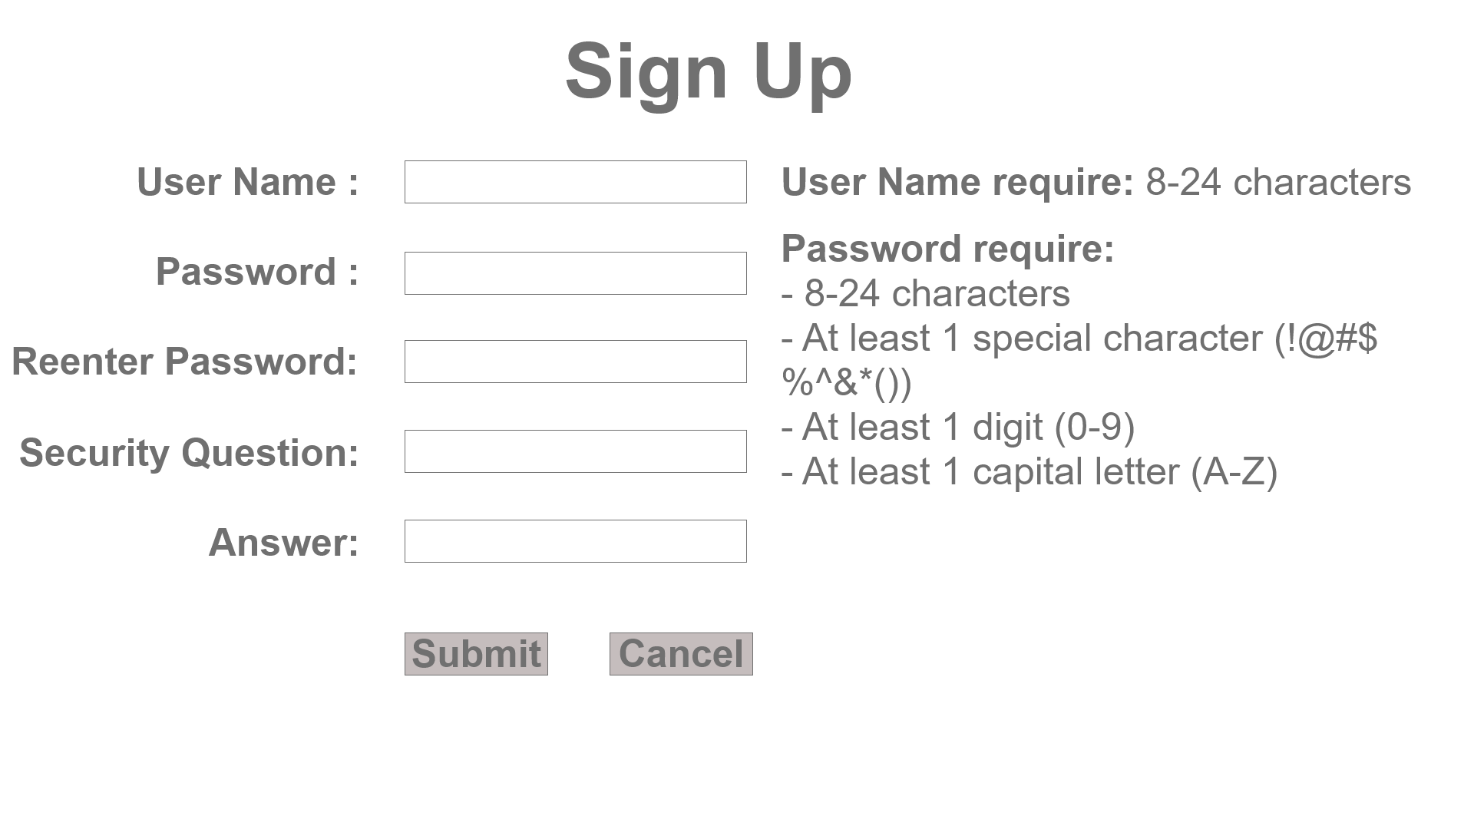

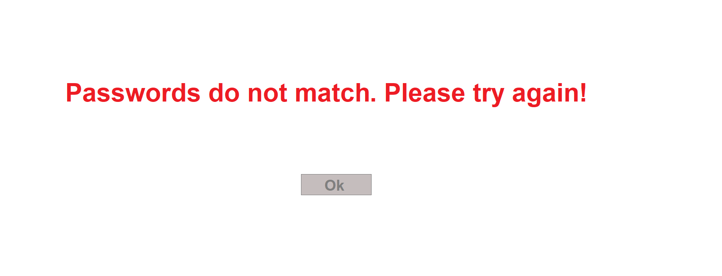

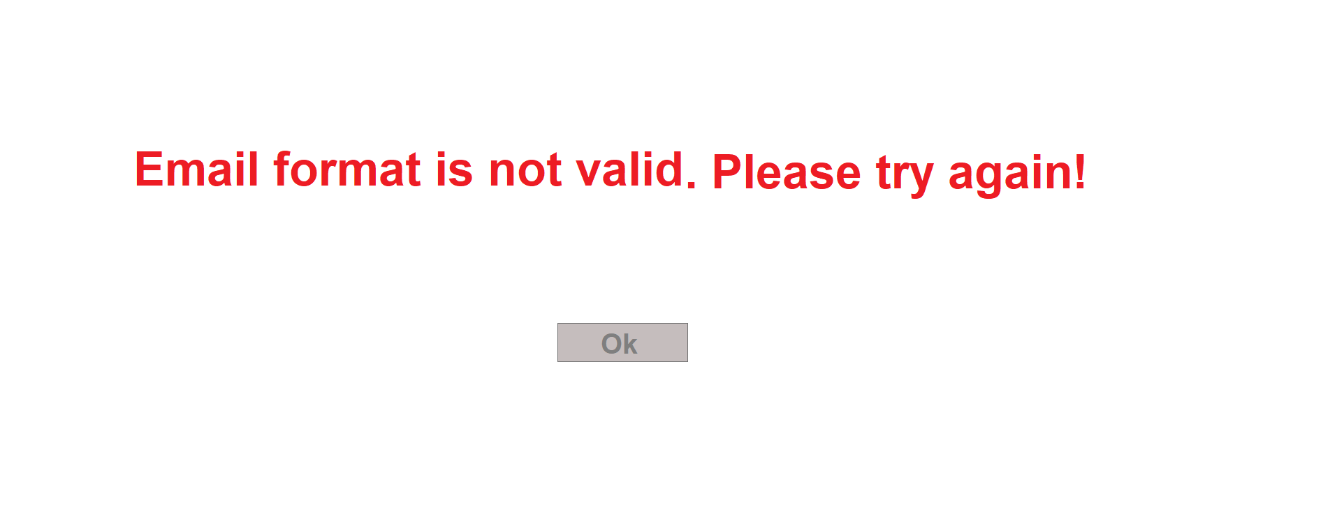

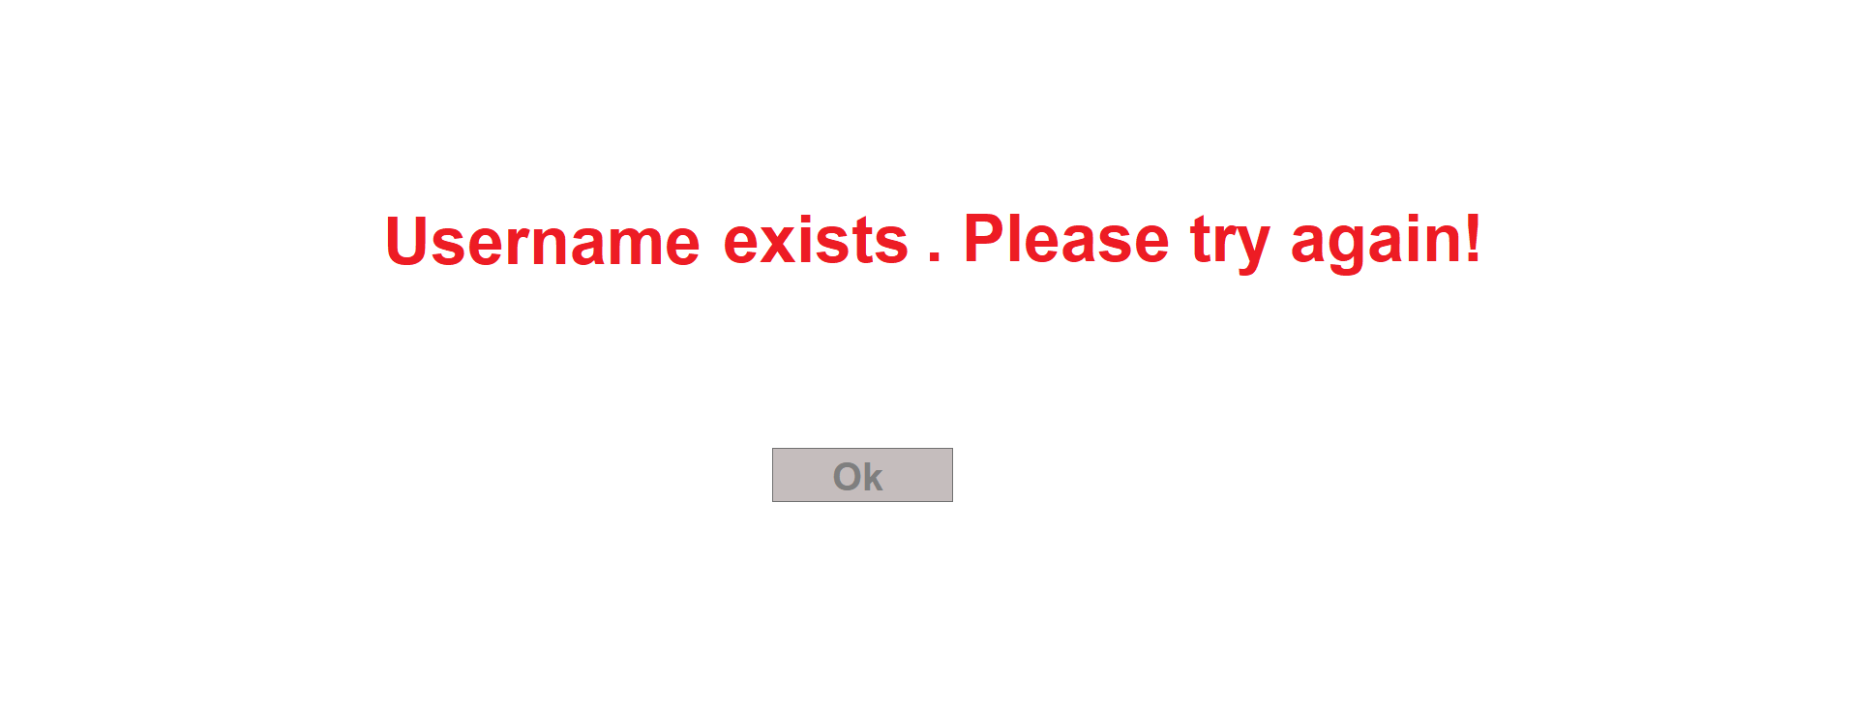

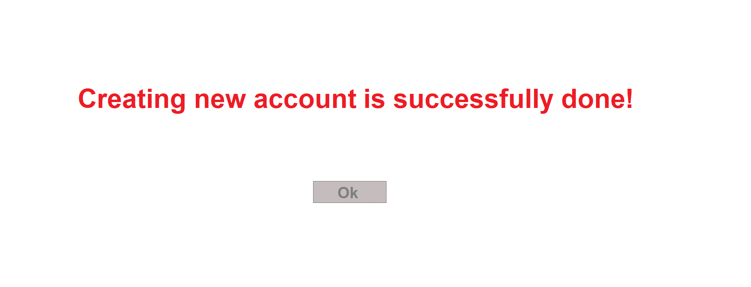

1. **Reset Master Password**

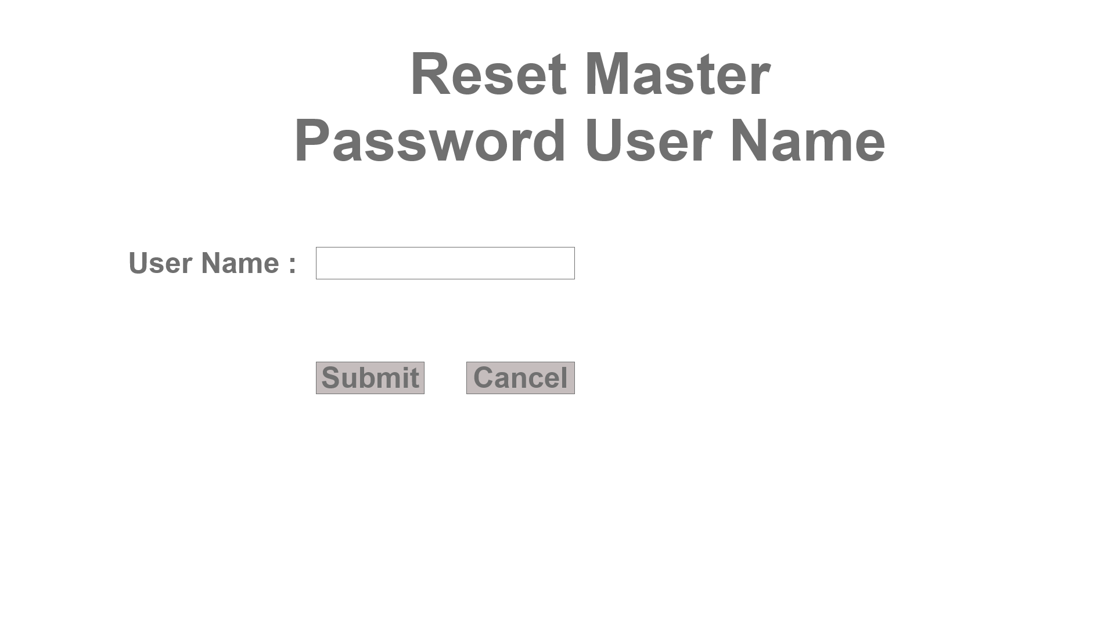

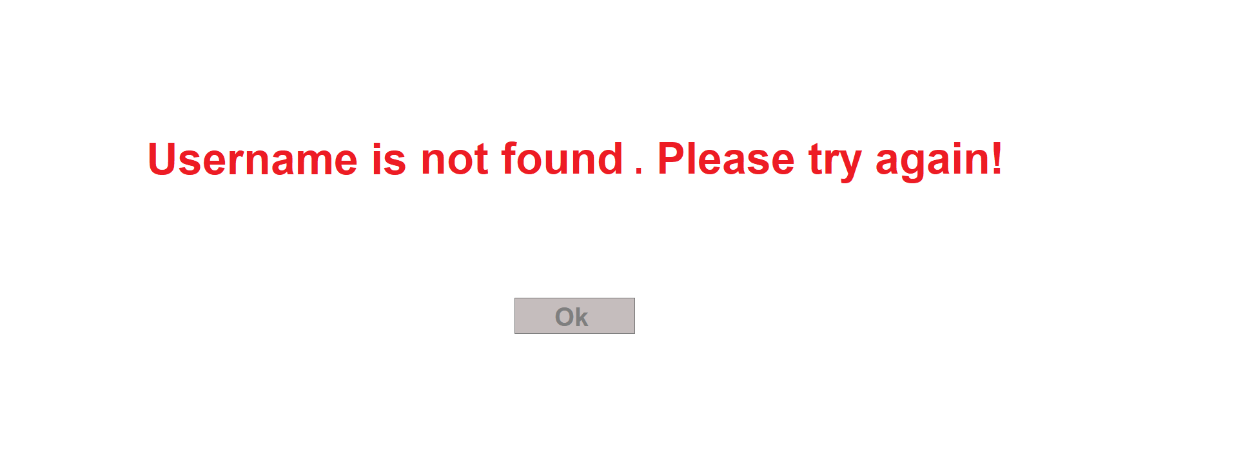

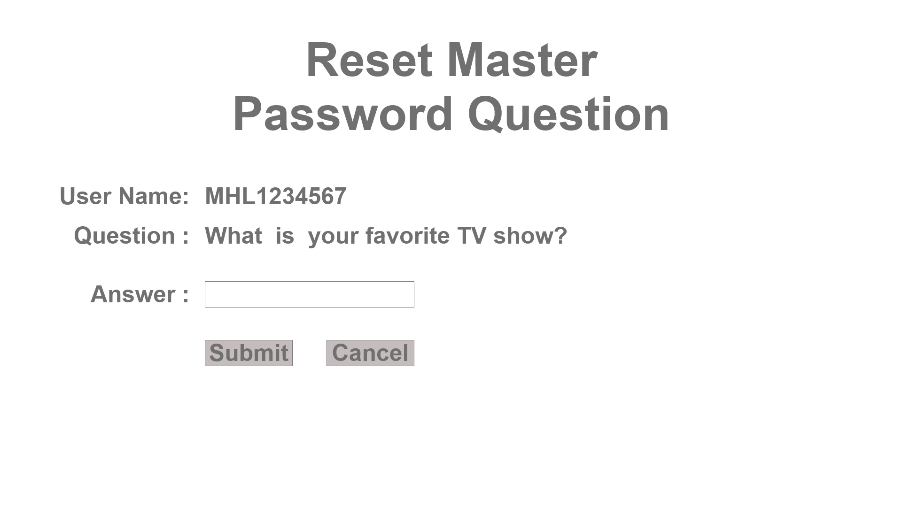

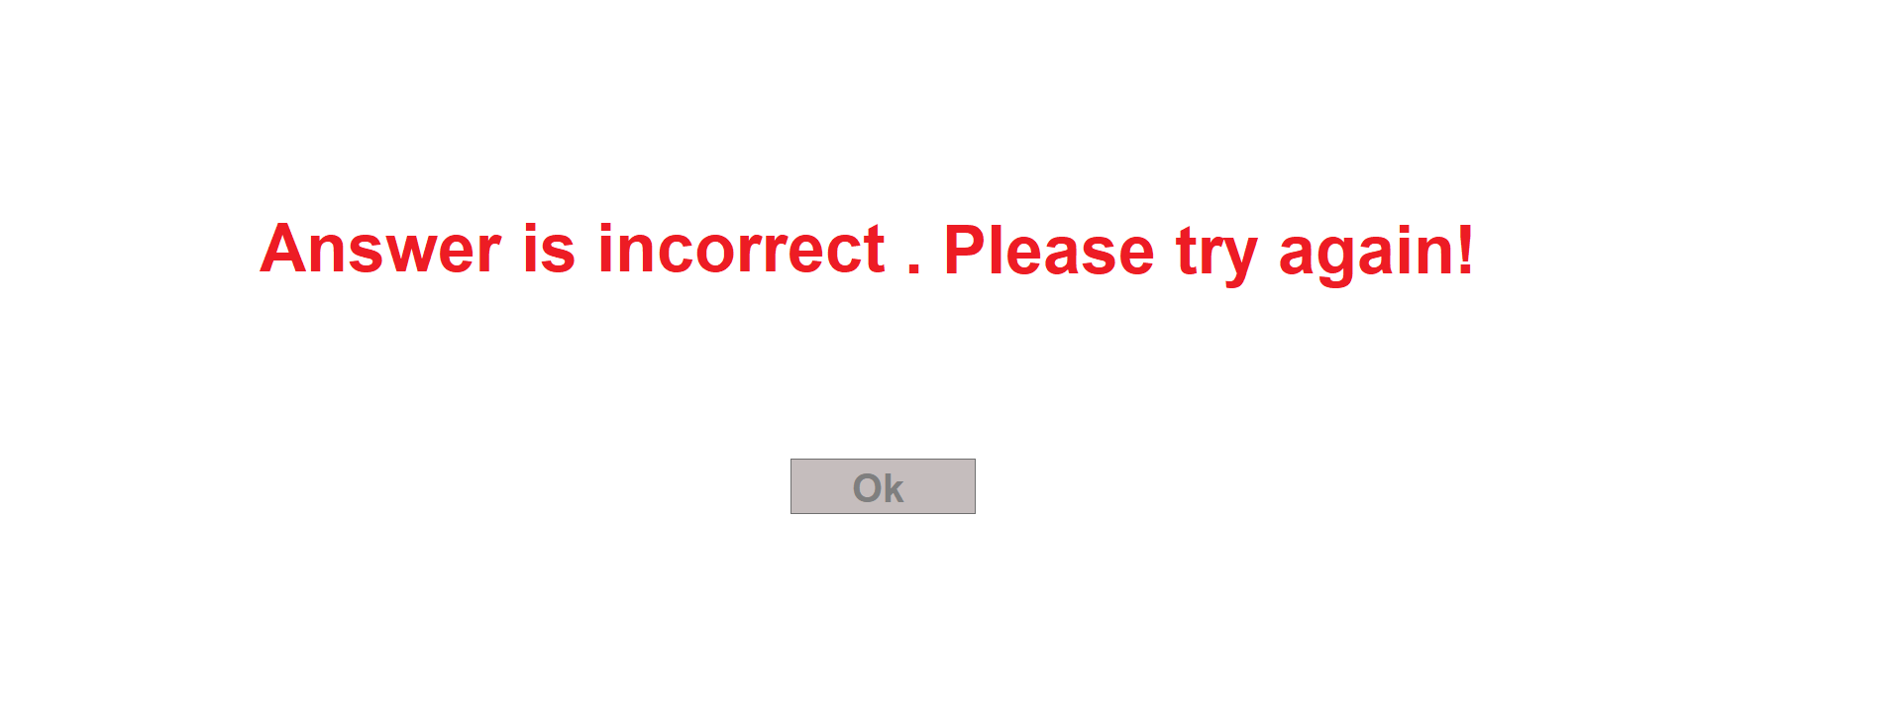

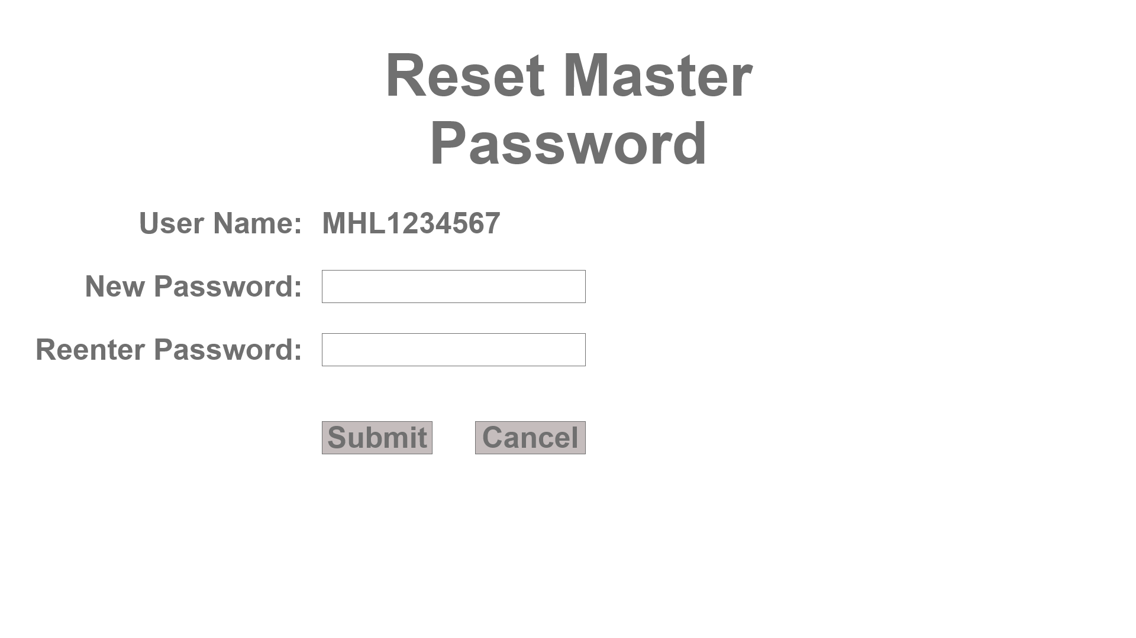



**C. Main menu:**

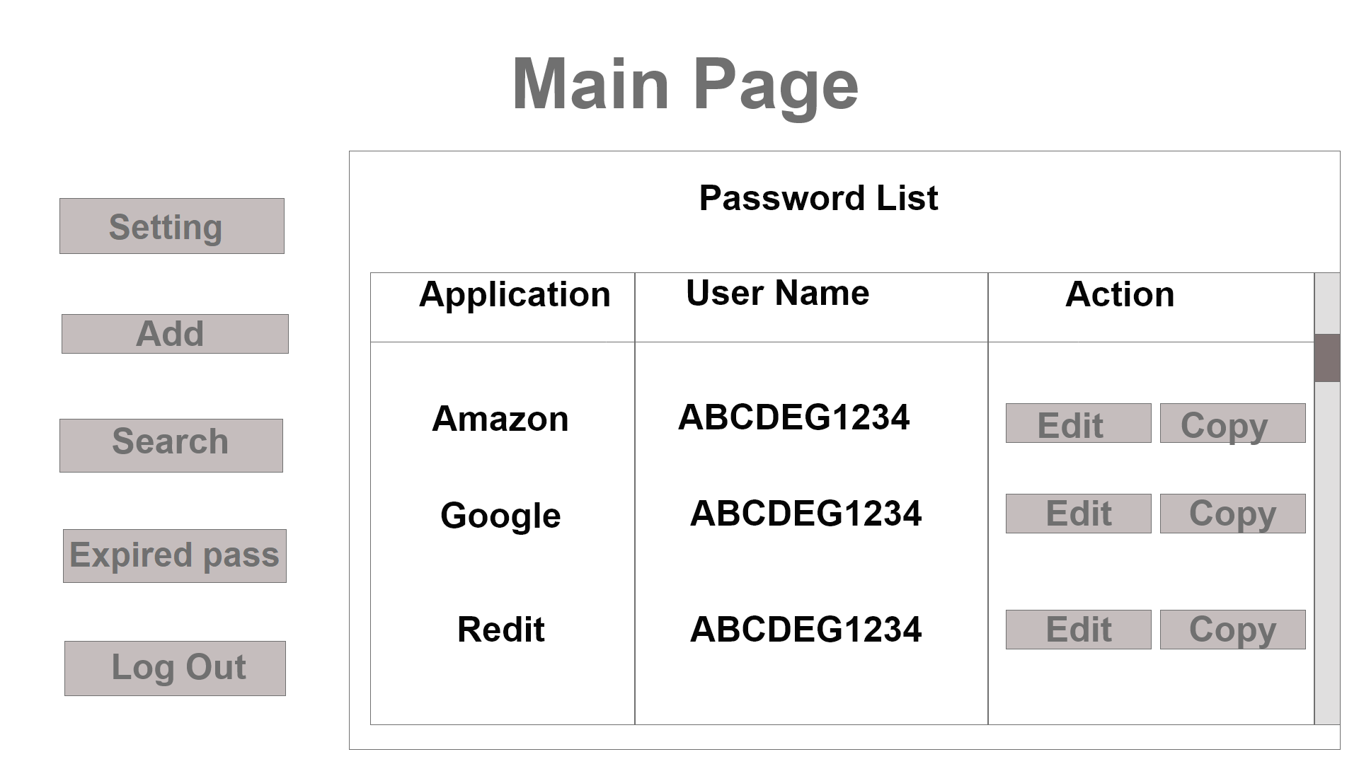

1. **Expired Password menu**

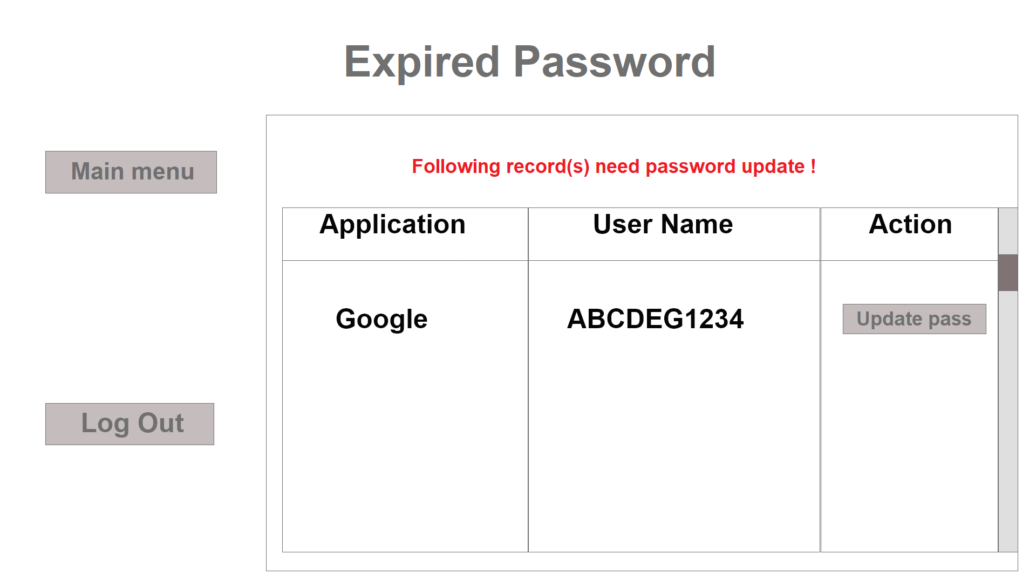

1. **Search menu:**

`

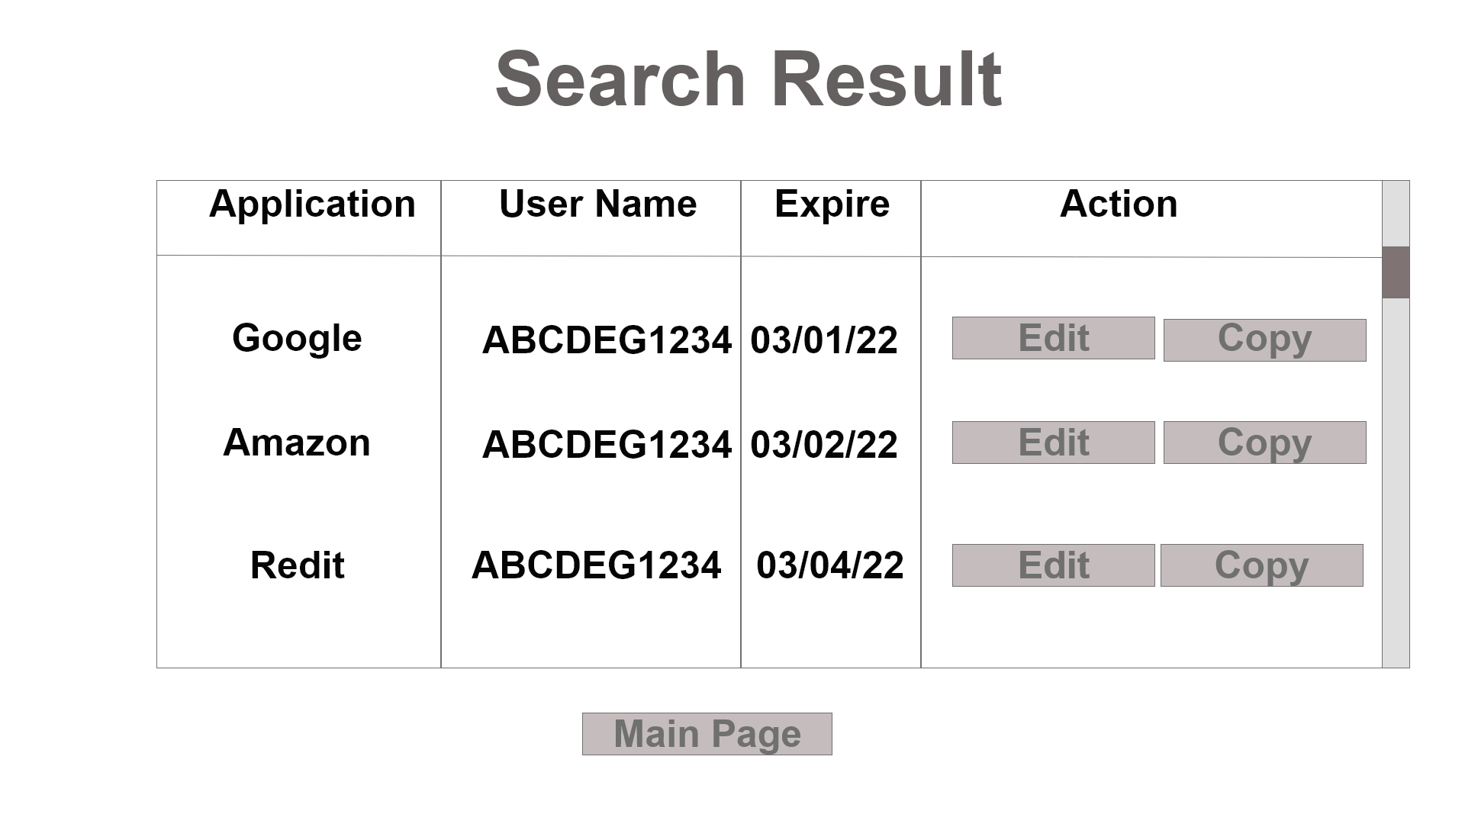

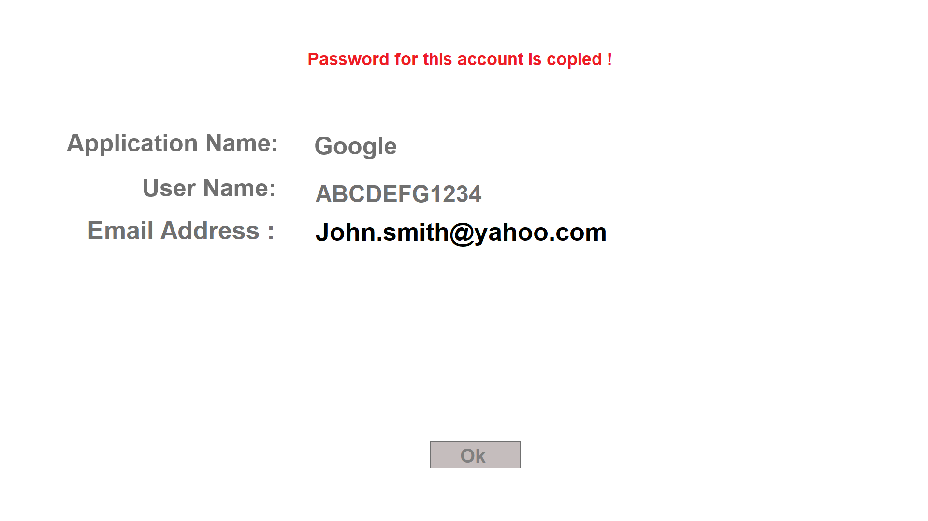

1. **Application Editing menu:**

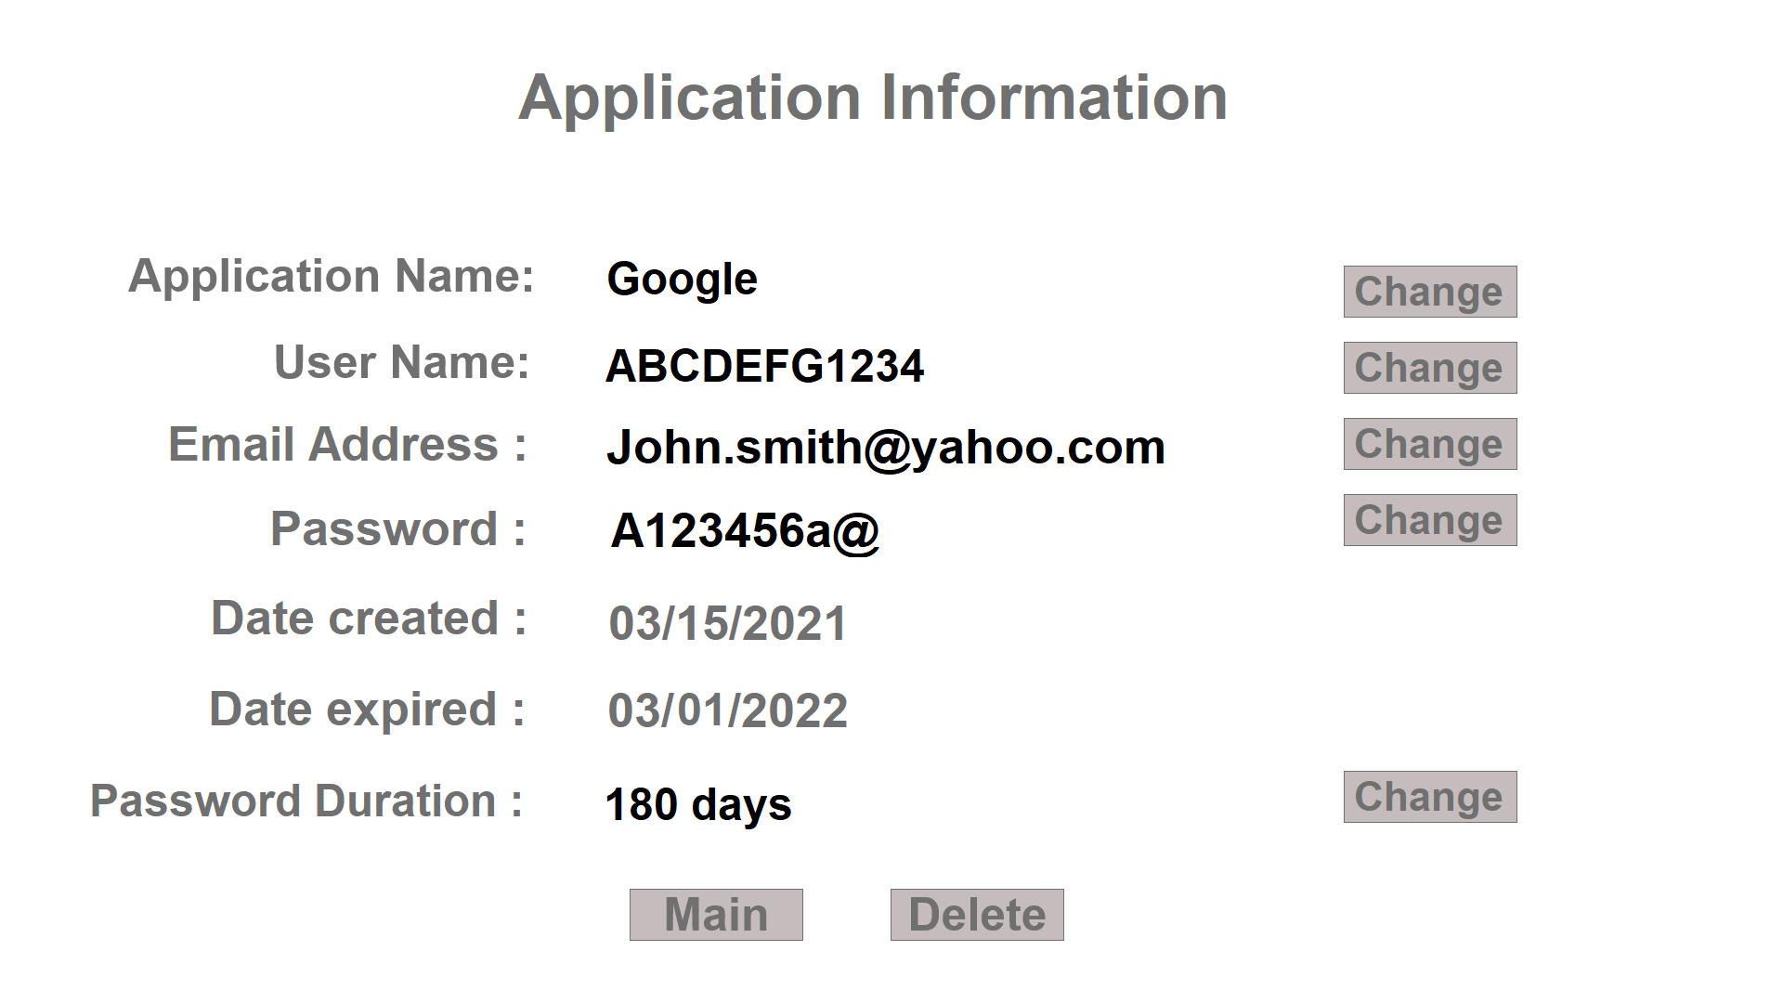

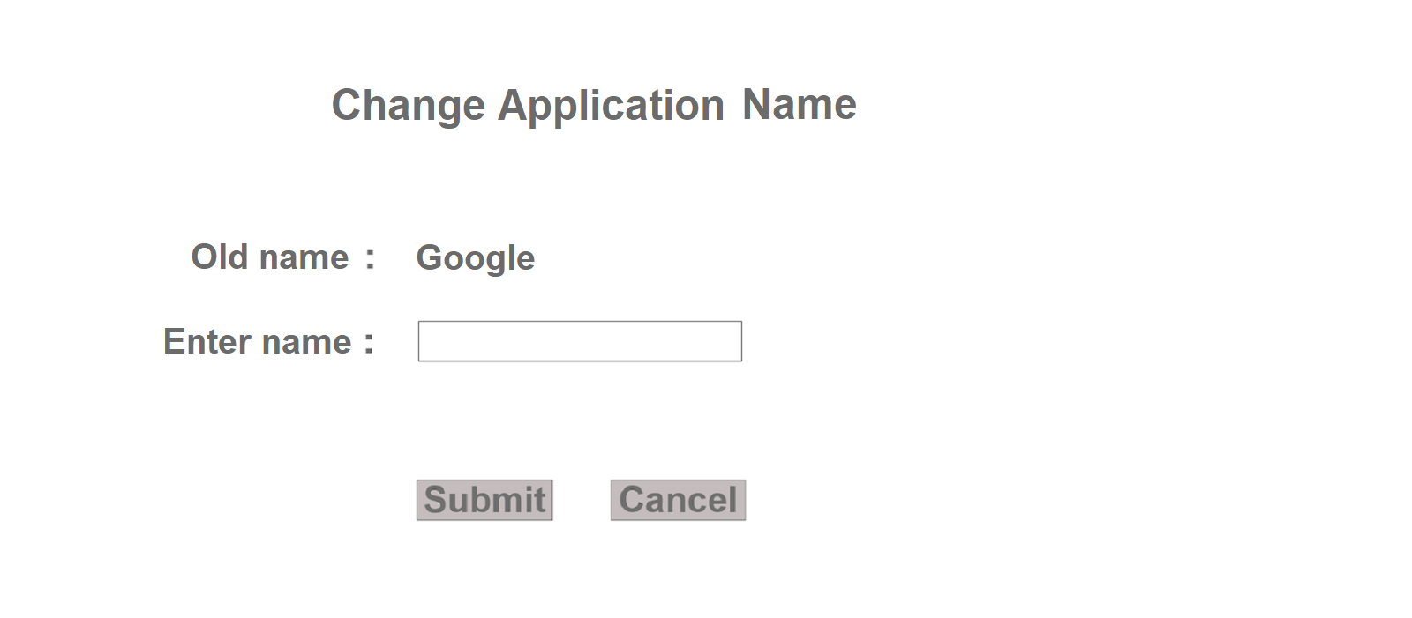

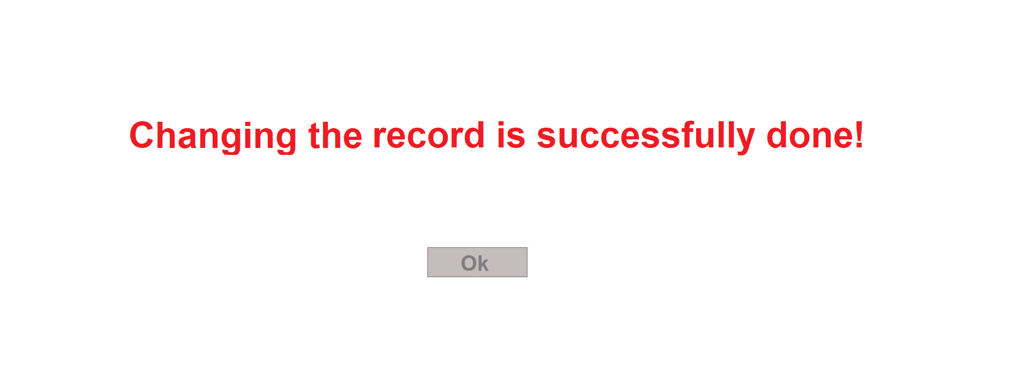

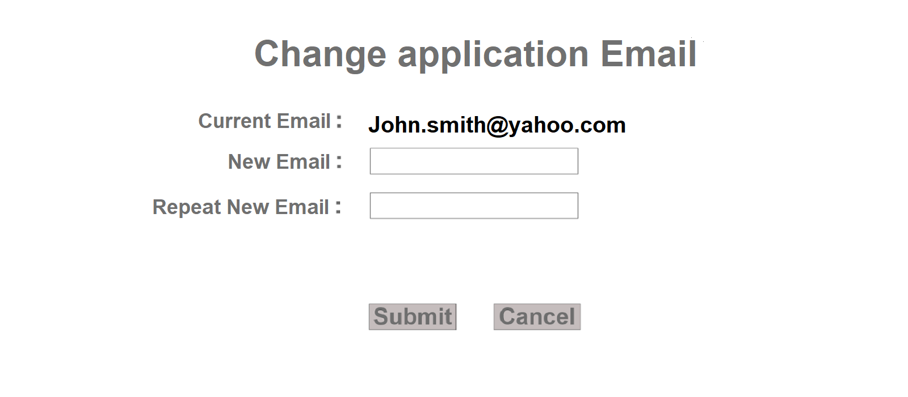





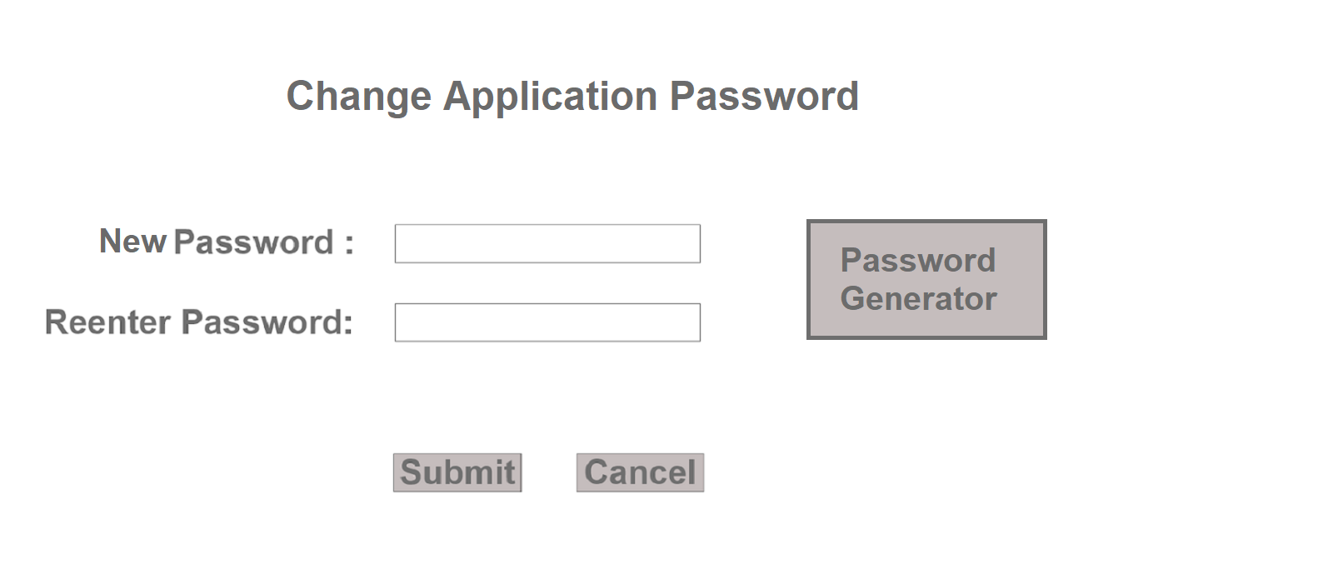



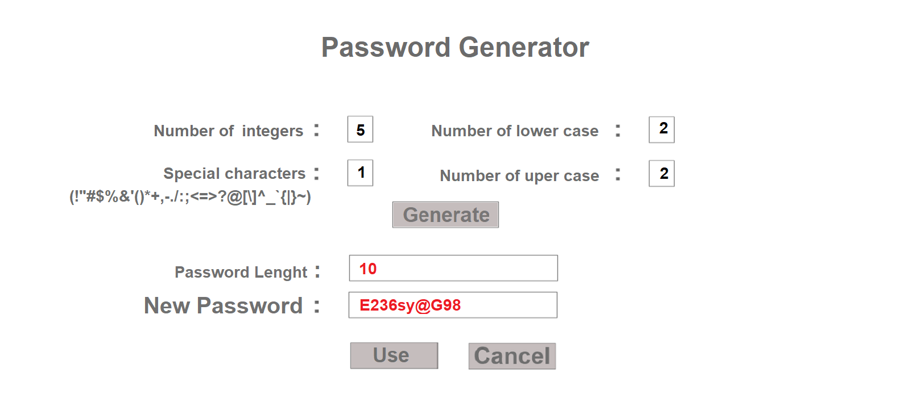

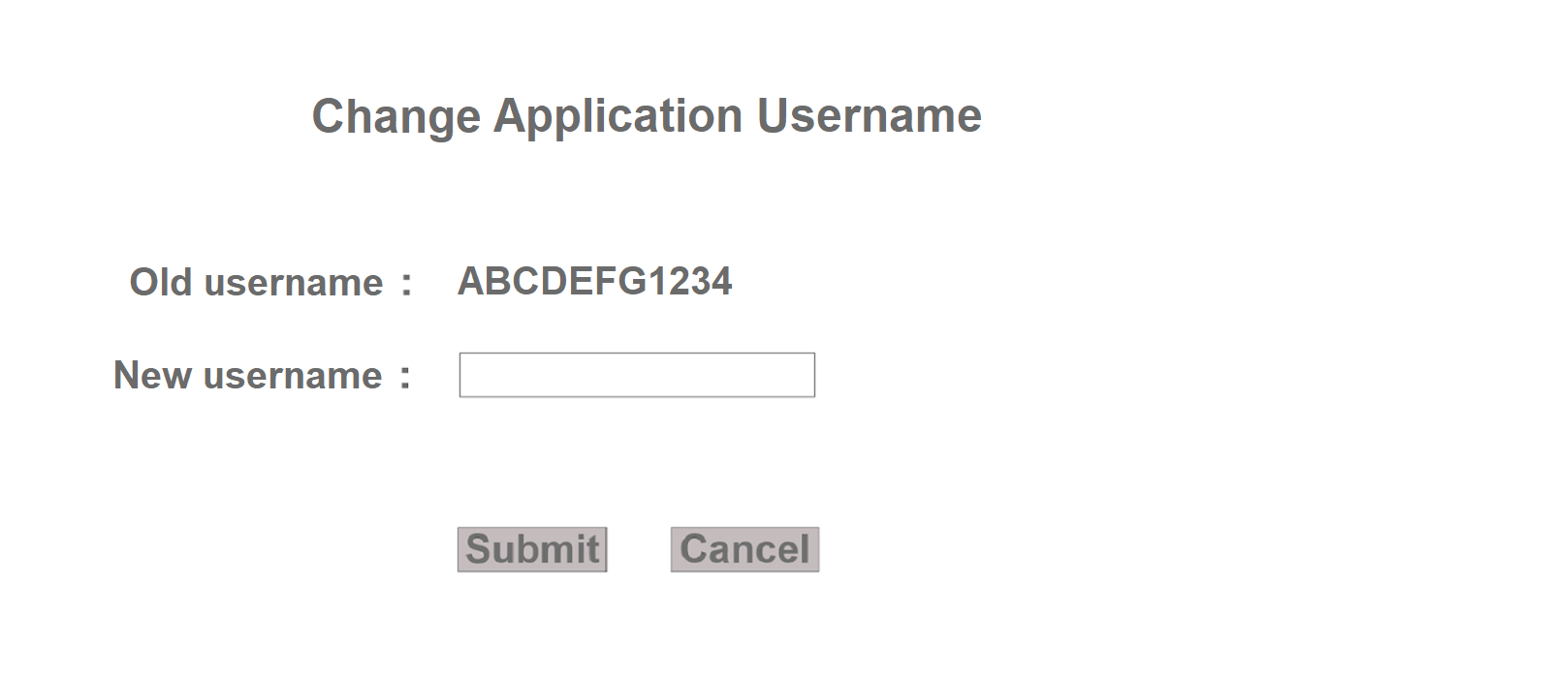



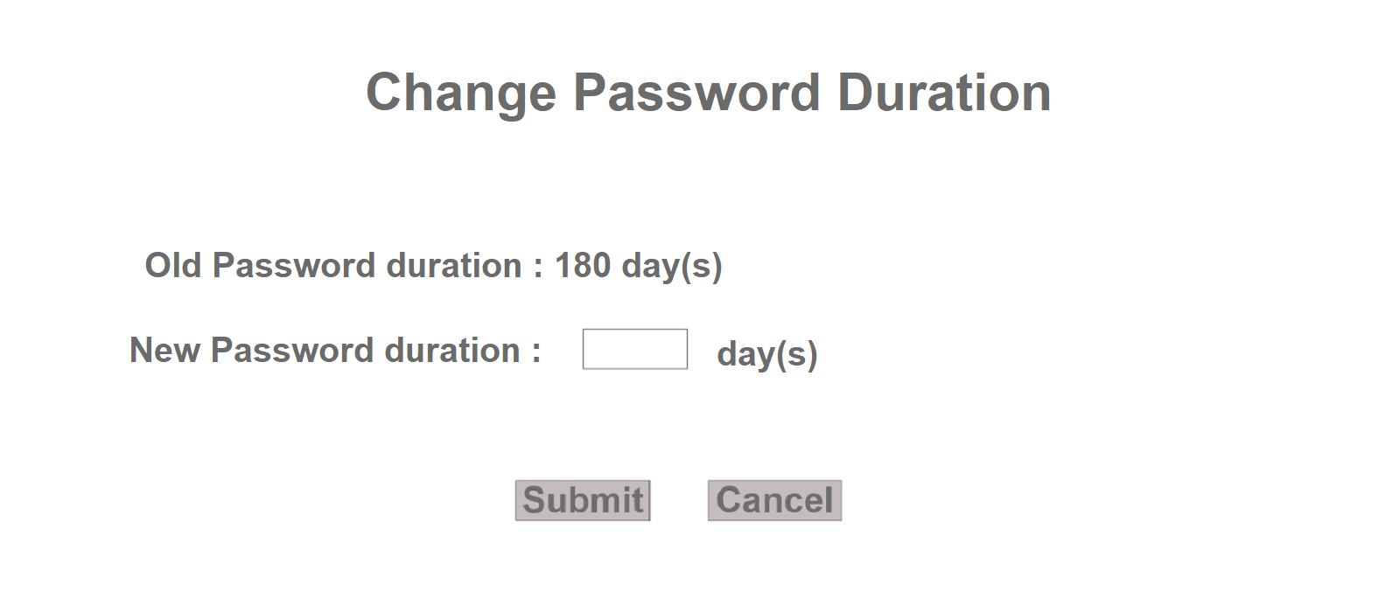

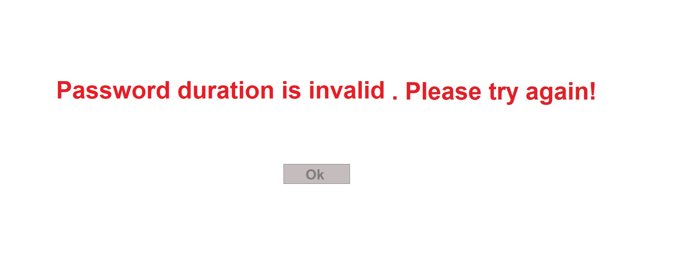

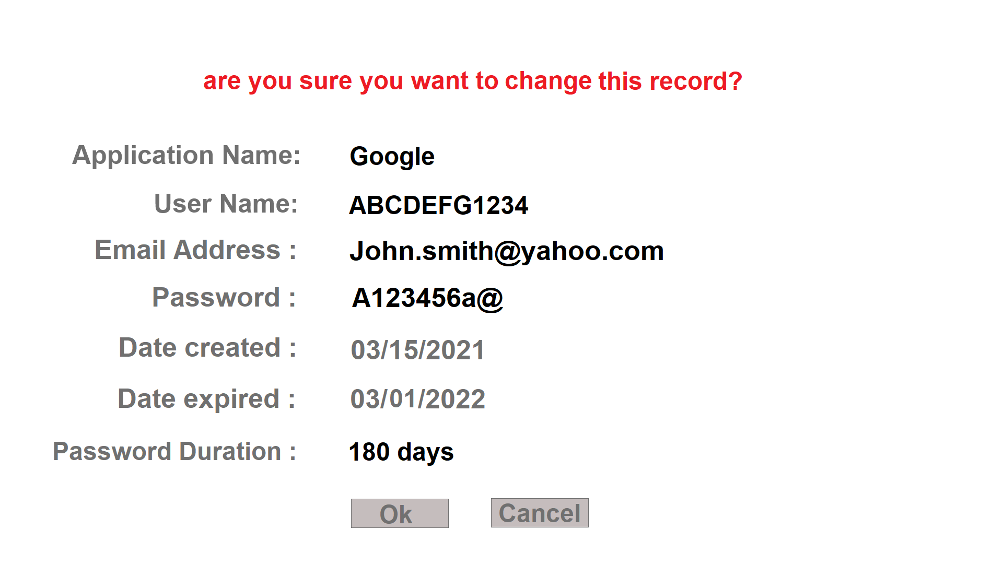

1. **Add Application menu**

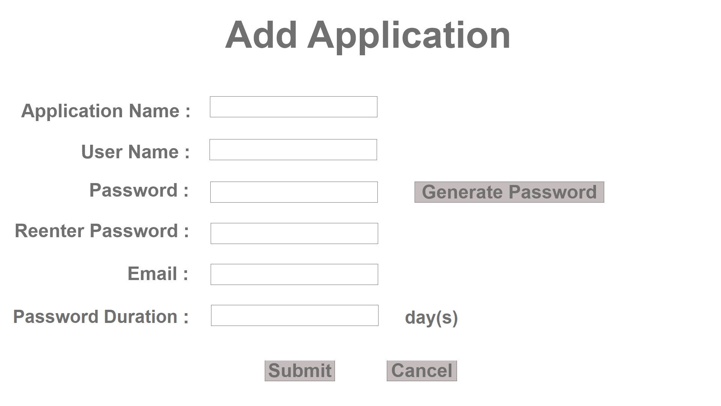







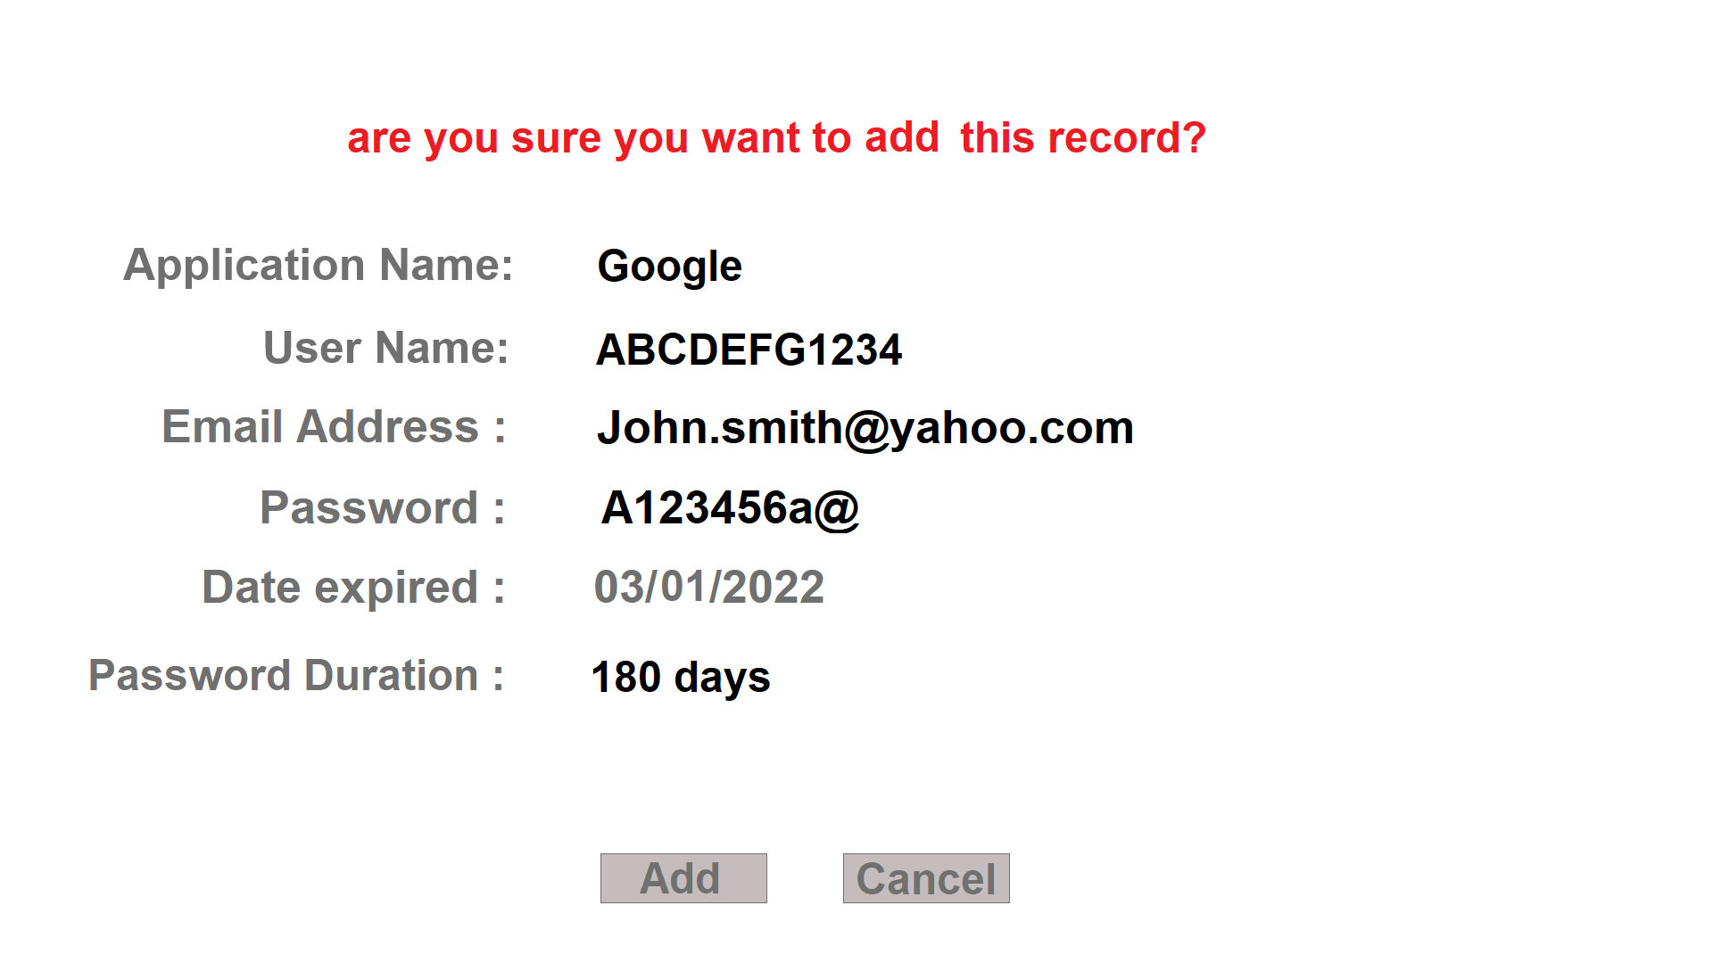

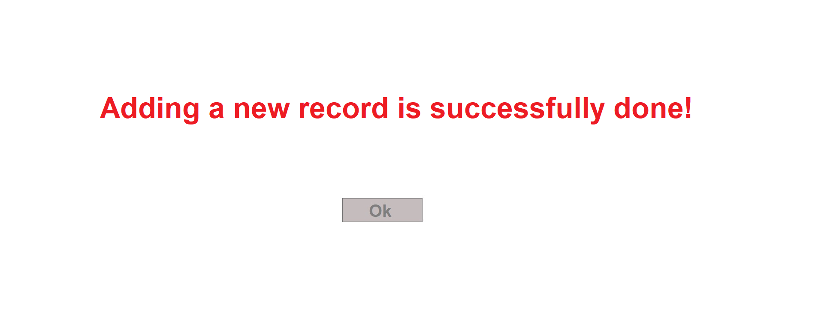

1. **Setting menu:**

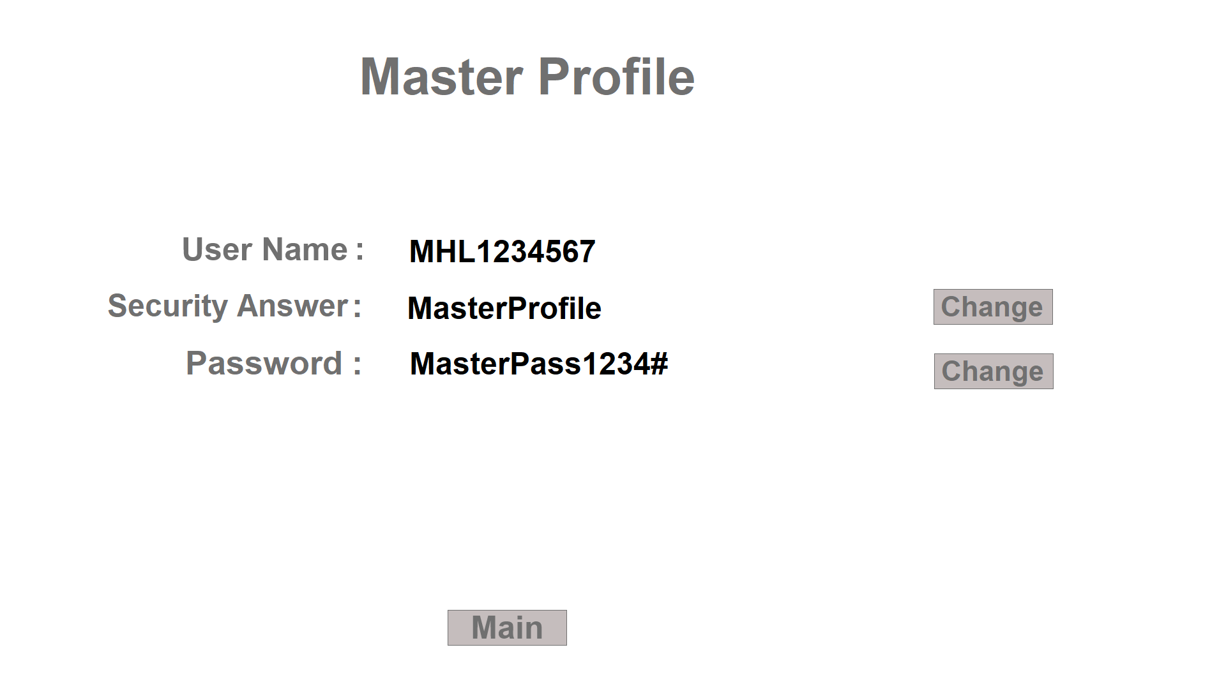

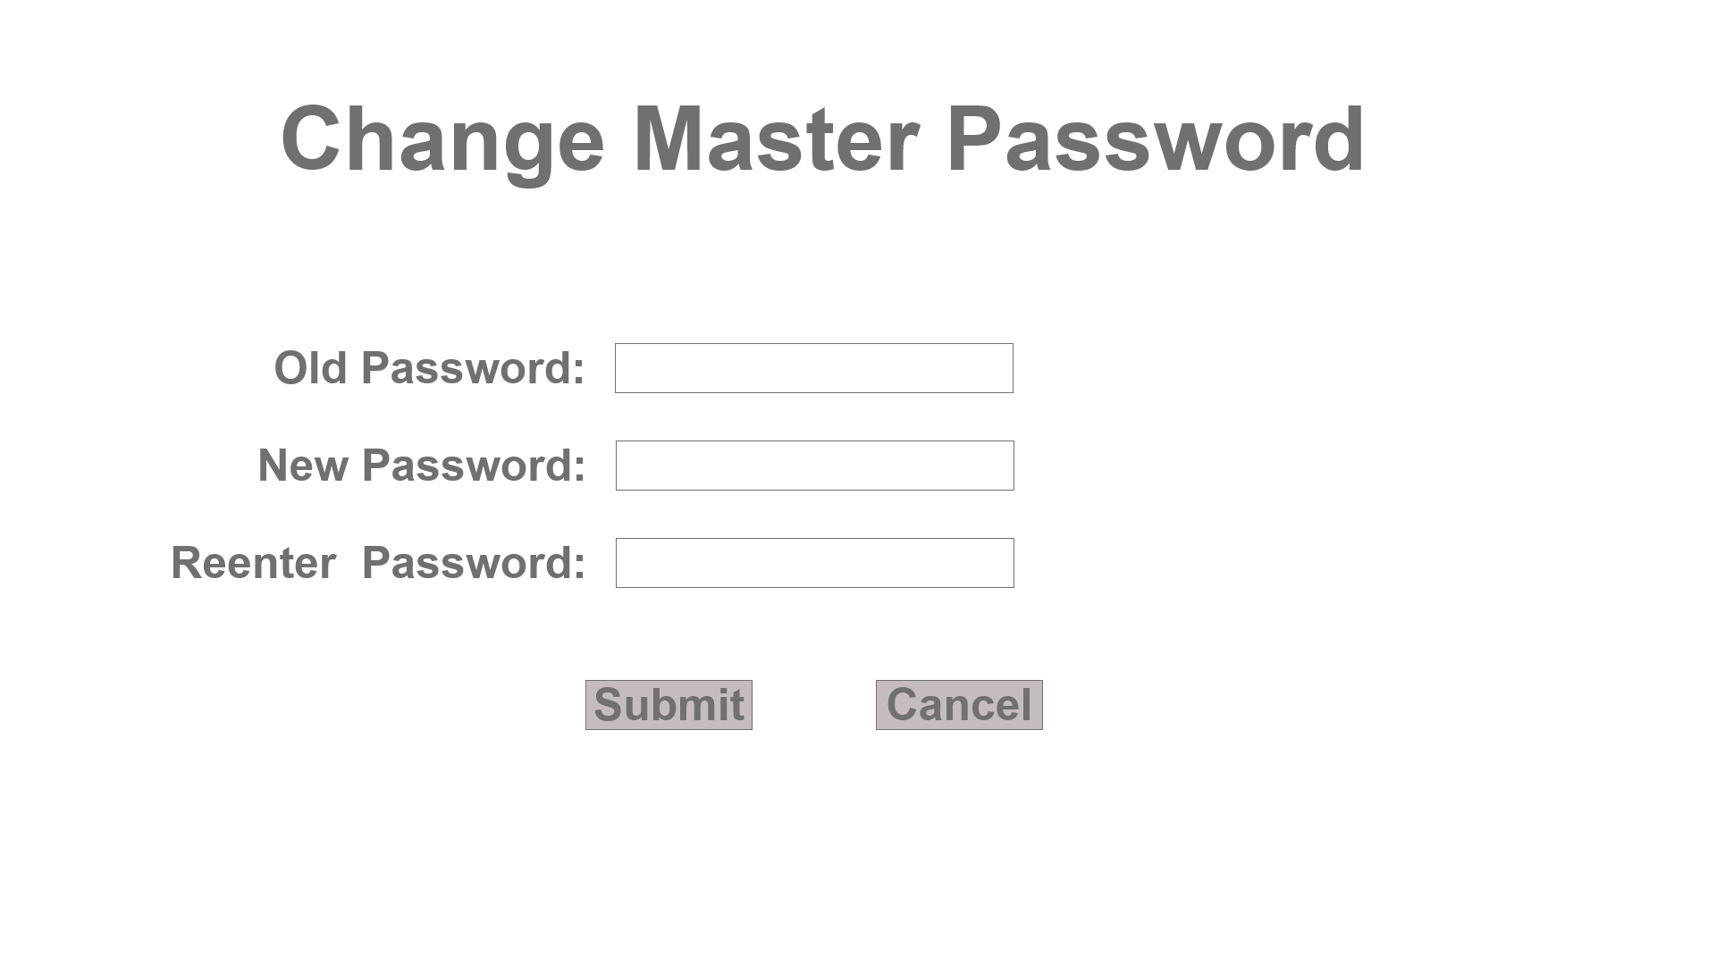

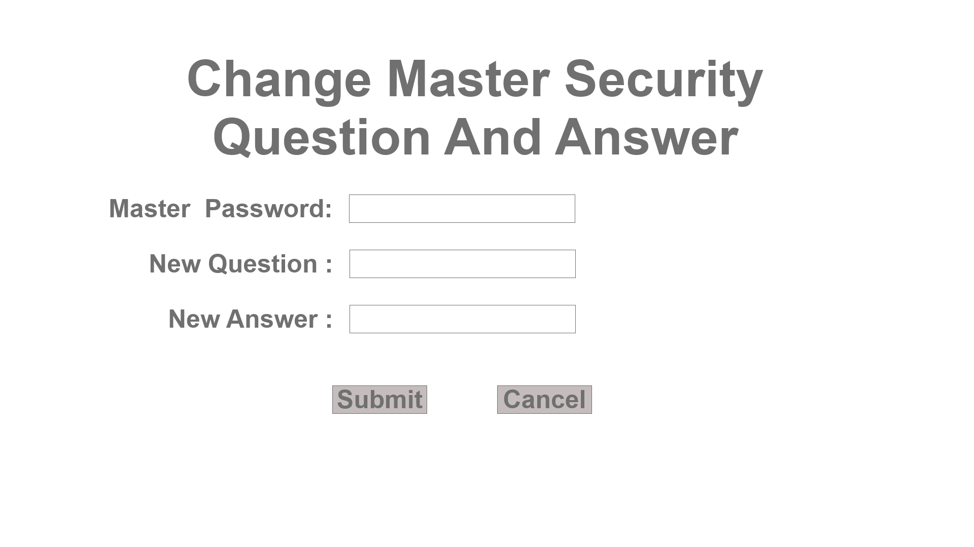

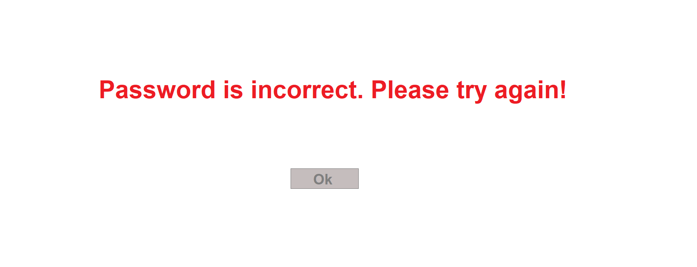

## Glossary

N/A